2022 9th International Power Electronics Systems and Applications (PESA)

Title:
Enhancing Wind Energy Harvesting by Industrial Data Intelligence

Abstract
Wind energy has been considered to be a promising alternative to current fossil-based energies. Large-scale wind turbines have been widely deployed to substantiate the renewable energy strategy of various countries. In this talk, challenges faced by academic and industrial communities for high reliable and efficient exploitation of wind energy are discussed. Industrial data intelligence is introduced to (partially) overcome problems, such as uncertainty, intermittence, and intense dynamics. Theoretical results and attempts for practice are both present.

Brief Bio
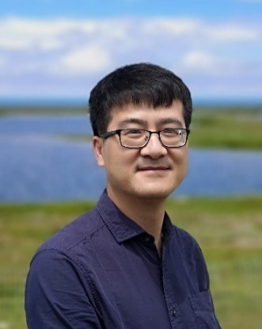
Bio: Qinmin Yang received the Bachelor's degree in Electrical Engineering from Civil Aviation University of China, the Master of Science Degree in Control Science and Engineering from Institute of Automation, Chinese Academy of Sciences, and the Ph.D. degree in Electrical Engineering from the University of Missouri-Rolla.
He has been an advanced system engineer with Caterpillar Inc., and a Post-doctoral Research Associate at University of Connecticut. Since 2010, he has been with the State Key Laboratory of Industrial Control Technology, the College of Control Science and Engineering, Zhejiang University, China, where he is currently a professor. He has also held visiting positions in University of Toronto and Lehigh University. He has been serving as an Associate Editor for IEEE Transactions on Systems, Man, and Cybernetics: Systems, IEEE Transactions on Neural Networks and Learning Systems, Transactions of the Institute of Measurement and Control, Processes, and Automatica Sinica. His research interests include intelligent control, renewable energy systems, smart grid, and industrial big data.

